Now, this is just one type of response. There are a few more important responses that we must know about.

30X: A response in the 300 range is used to signify redirection. For example, if you requested for page 1, but are being redirected to page 2. In this case, the response will say, “301 Moved Permanently to Location: page2”.

40X: These responses depict errors that occur due to the user’s fault. The most common response we have all come across is 404:Not Found error. We get this response when the page we have requested for does not exist.

Another example is the 403: Forbidden response. This comes when you request for a page that you are not supposed to visit.

50X: These responses occur when there has been some error on the server side. For example, if a website is not able to connect to its database due to some server side code error, you might see 500 internal server error.

So, these were some important responses sent in headers.

You must remember these ranges and their meaning well, since by looking at this we can get an idea of what kind of response the server wants to give us.

Now, after the first line of the response headers, we see some standard HTTP response headers. These headers basically tell the browser about the response and how to handle it. They are like the configuration settings sent by a web server to be stored in the browser for later usage.

In these settings, you may choose to study about some of them in detail. These include the Content Security Policy, Referrer Policy, Allow Origin, X-powered-by, etc. We will not be covering these in our topic, but you can read more about them online.

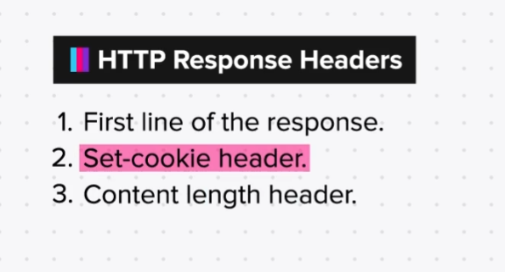

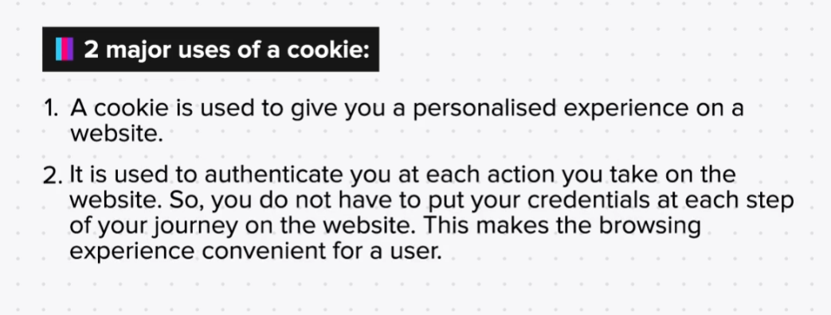

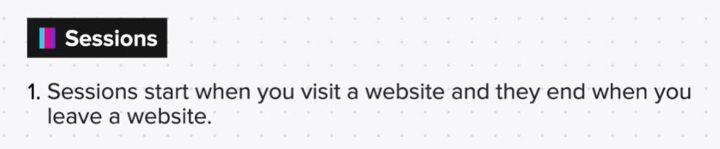

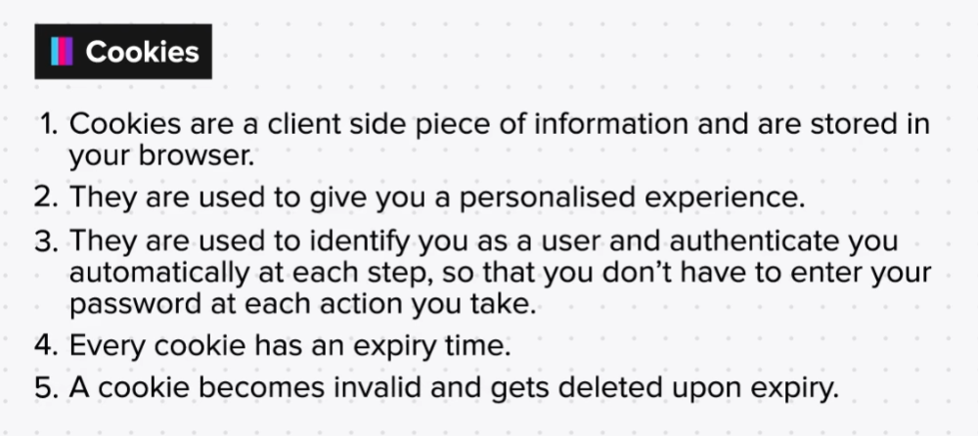

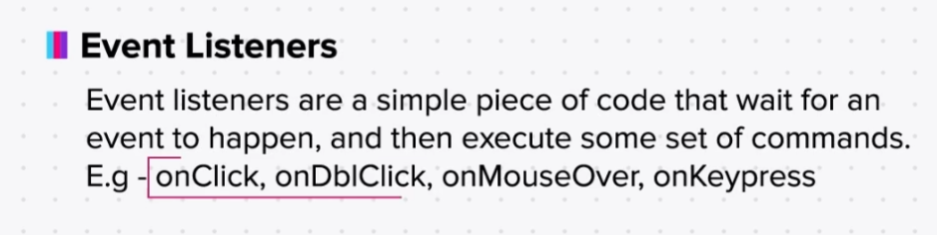

Event Listeners

Here is a list of some commonly used event listeners.

1. onclick and ondblclick: In this case the eventhandler listens to a “click” event. If any user clicks on the web page, this event listener will get triggered and will show an alert.

Eg:

<html>

<body>

<button name="test_button" onclick="alert('clicked!')" ondblclick="alert('double clicked!')">Click me!</button>

</body>

</html>

2. Iframe onload: Another very common event listener is ‘onload’, which simply gets triggered when some element (image, body, iframe, video etc. has finished loading.

Eg:

<html>

<body>

<iframe src="https://ipchicken.com" onload="alert('lo')"></iframe>

</body>

</html>

3. Image onerror: In this event listener, the src attribute in the img tag looks for the file given in the URL. But, if the url raises an error and cannot be accessed, we can have an onerror event listener to display an appropriate message to the user.

Eg:

<html>

<body>

<p>

Example of onerror event:

</p>

<img src="x" onerror="alert('No image found');">

</body>

</html>

4. Using getElementById method: Here, we ask the user to input her name using <input> tag. Then we access this input using the getElementById method, and add a “Hi”, to it. Then we display it on the alert box. This alert is displayed when the user clicks on the button after giving the input.

Eg:

<html>

<body>

<input type="text" placeholder="Enter your name" id="textfield1">

<button onclick="alert('Hi '+document.getElementById('textfield1').value)">Click Me</button>

</body>

</html>